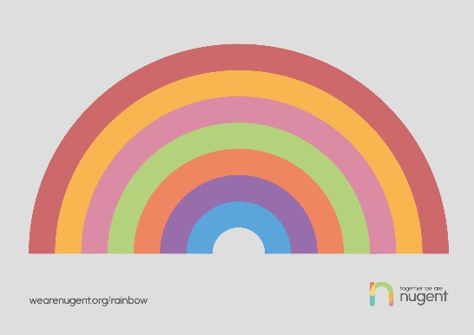

Wellbeing Support Online – Some Useful Signposts

Information
- MIND
- Young Minds
- Head Meds (Powered by Young Minds)
- Royal College of Psychiatrists
- Mind Ed
- NSPCC Bi-Polar UK
- Charlie Waller Memorial Trust

Support
- Kooth (Free, safe and anonymous on line support for young people aged 10-25
- Samaritans
- BEAT (Eating Disorders)
- Papyrus (Prevention of young suicide)
- Childline
- The Mix (information & support for under 25’s)
- Young Minds
- Youth Access (advice and counselling network)

Resources
- ‘Stay Alive’ App
- Calm Harm App (Self-harm support/distraction app)
- Headspace (mindfulness/relaxation app)
- Anna Freud Schools in Mind

Remember to use your daily check in calls with school or any other external agencies you are already working with to discuss any concerns you may have

